**Odds of Delayed Graft Function Adjusting for Donor Age and Cardiac Death**

2/15/2024, Kath Fillman

**Introduction.** An analysis of the odds of delayed graft function based on donor age and cardiac death prior to donation based on a study on Long Term Deterioration of Kidney Allograft Function. This analysis aimed to determine how donation after cardiac death affects the odds of DGF, after adjusting for donor age and how donor age affects the odds of DGF, after adjusting for donation after cardiac death.

**Dataset.** The dataset dekaf_dgf was provided by the instructor and originated from the Long Term Deterioration of Kidney Allograft Function study conducted at the university of minnesota. It contained data from 724 participants who received deceased-donor kidney transplants, where data was collected to study long term deterioration of kidney allograft function. Data collected included a binary variable of if delayed graft function occurred (dgf), a binary variable of if the kidney was received after a cardiac death of the donor (dcd_yn), and the age of the kidney donor (agedonor16).

**Exploratory Data Analysis.** Of the 724 participants in the study, 467 had delayed graft function. There were 62 donations after cardiac death, about 3% (22 participants) of which had delayed graft function (table 1). The vast majority of participants had neither delayed graft function nor a donation fryer cardiac death (figure 1).

Donor age is not normally distributed (figure 2). The mean age for donors is 25.59 years old. For those without delayed graft function the age is 24.7 compared to 28.6 of those with delayed graft function. The standard deviation for all ages is 15.06 years; 15.2 years for those with delayed graft function and 14.1 for those without (table 2).

**Methods.** Using a chi-squared test, it was found that there is a statistically significant association between delayed graft function and donation after death. Using a t-test, it was also found that there is a statistically significant relationship between age delayed graft function as well as age and donation after death. A logistic model was then constructed using the glm() function in R; p values less than 0.05 were considered statistically significant. All analyses were performed in R-studio version 2023.12.1, build 402 using R-version 4.1.3.

**Results.** All variables used in the model (dgf, dcd_yn, agedonor16) were statistically significant. The model is log(odds(DGF))=0.1649+2.1680(donation after death (y/n))+1.0197(donor age). Using the Hosmer-Lemeshow goodness of fit test, a p-value of 0.02175 is returned. The null hypothesis fails to be rejected, meaning that this model fits the data well.

**Conclusions.**

Donation after cardiac death increases the odds of delayed graft function after adjusting for donor age. The odds ratio in this case is 2.1680. This effect is statistically significant. The 95% confidence interval is 1.2385 to 3.7950, which does not include 0 and thus supports the p-value (0.0068) in the conclusion of significance (table 3).

The odds of delayed graft function increase with donor age when adjusted for donation after cardiac death. It increases by 0.0197% for every year increase in donor age. This effect is statistically significant. The 95% confidence interval is 1.0075 to 1.0320 which does not include 0 and thus supports the p-value (0.0015) in the conclusion of significance (table 3).

**Appendix**

**Table 1. Delayed graft function vs donation after cardiac death**

|  | | **Donation after Cardiac Death** | | |
| --- | --- | --- | --- | --- |
| **No** | **Yes** | **Sum** |
| **Delayed Graft Function** | **No** | 517 | 40 | 557 |
| **Yes** | 145 | 22 | 467 |
| **Sum** | 622 | 62 | 724 |

**Table 2. Donor age summary statistics**

|  | **Delayed Graft Function** | | **Total** |
| --- | --- | --- | --- |
| **No** | **Yes** |
| **Mean** | 24.7 | 28.6 | 25.59 |
| **Standard Deviation** | 15.2 | 14.1 | 15.06 |

**Table 3. Model Summary**

|  | **Delayed Graft Function** | **Donation After Death (yes)** | **Donor Age** |
| --- | --- | --- | --- |
| **log(odds)** | 0.1649 | 2.1680 | 1.0197 |
| **95% Confidence Interval** | 0.1117, 0.2435 | 1.2385, 3.7950 | 1.0075, 1.0320 |
| **p-value** | N/A | 0.0068 | 0.0015 |

**Figure 1.**

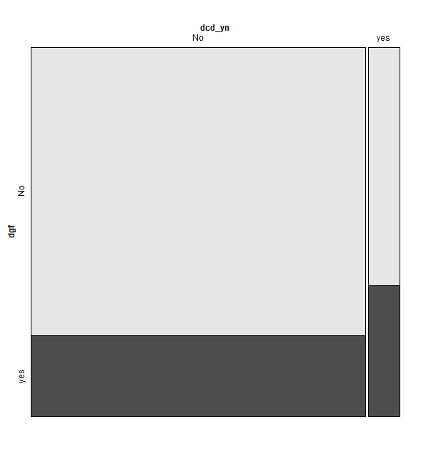

**Figure 2.**

